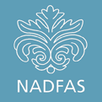 | RICHMOND & DISTRICT DECORATIVE AND FINE ARTS SOCIETY  February 2015 Newsletter
February 2015
Dear Members
I want to start off with two thank yous.
Thank you firstly to Catherine and Maurice Parry-Wingfield for hosting the lunch at their magnificent Montpelier Row house on Saturday 7 February. There were 36 members there and it was lovely - really lovely - to meet several new members.
Thank you also to Pauline Tuft for producing a wonderful spread of food. The whole affair was enjoyed by everybody.

Recent visits
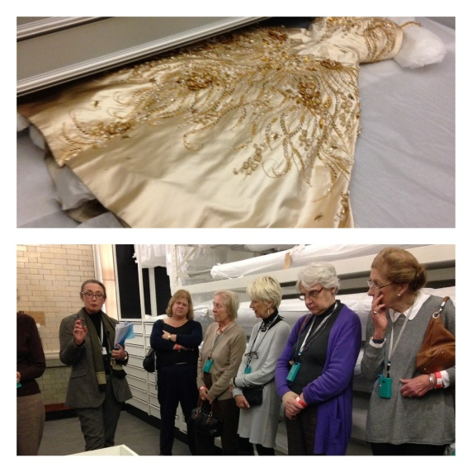 | In November 2014 we had an excellent visit to the Clothworkers' Centre of the V&A.  Here the group is entranced by the detail on an embroidered Norman Hartnell gown worn by the young Queen Elizabeth II on her state visit to France in 1957.
December saw an excited group of us arriving early for Breakfast at Sotheby's. Adrian Biddell, Senior Director, gave us a fascinating preview of 19th Century European paintings included in his next auction.  We then also browsed around on our own, including paintings and memorabilia from the estate of Sir Winston Churchill which went under the hammer a few weeks later. | 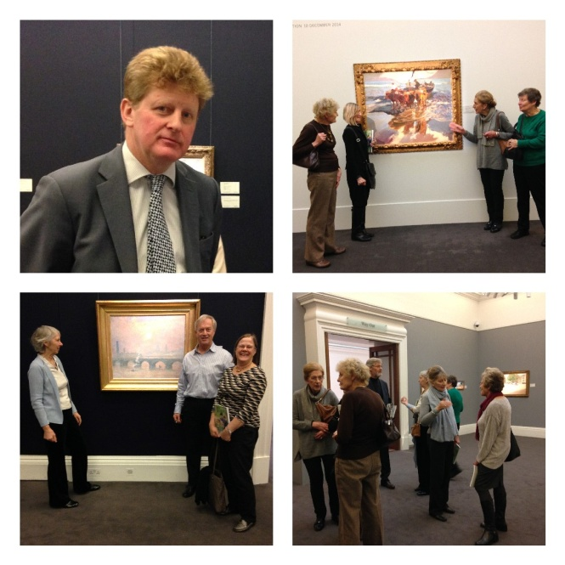
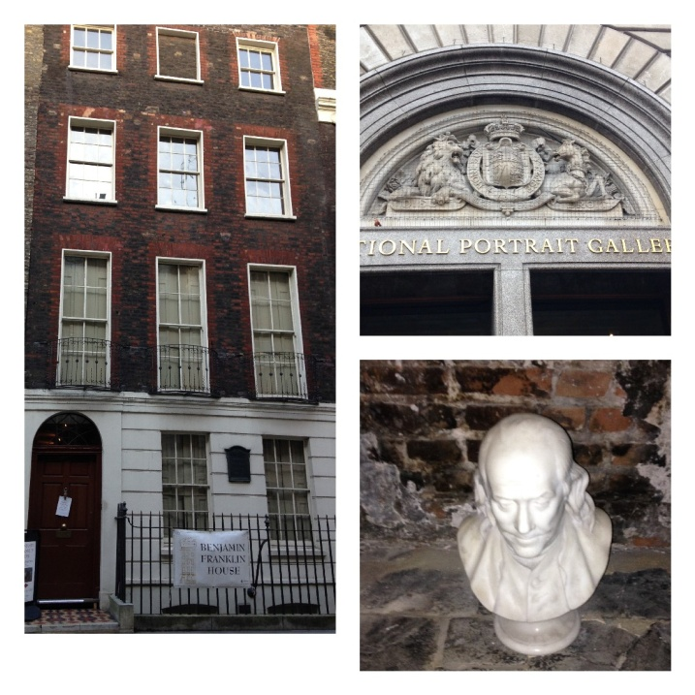 | The first visit of 2015 was a visit to Benjamin Franklin's House coupled with a themed visit to the National Portrait Gallery where our guide, Sarah Ciacci, picked out portraits of notable contemporary Londoners.

Lost property
A pearl earring was lost at Duke Street Church on the evening of our last lecture on 3 February. It's too much to hope that any of you have found it but you never know! A folding black umbrella was left behind after the lunch on 7 February - please phone me to reclaim it.

Application forms
The application forms for the next series of visits, study day and summer party are attached or enclosed - they cover the period from April to June 2015.
Please note that the study day on 13 May 2015 is not as previously advertised. Ben Street has cancelled all his speaking engagements at short notice (I don't think we'll be inviting him again) and we are very grateful to Patsy Erskine-Hill who will take his place. Patsy was going to be presenting the study day in the autumn but she is free on 13 May.
Most of our events are very popular and they get booked up quickly. We are very aware of this and we try to accommodate everybody, for example, by arranging a second or third visit to a venue but sometimes it is just not possible. We do our best, so please bear with us if your application is not successful.
If you ever have a problem downloading an application form from one of my emails, you can always get them from the website or phone me and I'll pop one in the post to you.

Payment by bank transfer
You can pay for visits, study days and social events of course by bank transfer to HSBC, Sort Code 40-38-18, account number 31024191. If paying by bank transfer, please send an email to Jenny@Lebus.net so that Jenny can look out for it.

The 10-minute presentations
We are now having 10-minute presentations before the monthly lectures - perhaps not every month, just when there is something interesting to say.

As many of you will know, Dr Florian Schweizer, the Chief Executive of NADFAS, gave the first such presentation before the lecture earlier this month. The next one on 3 March will be given by Catherine Parry-Wingfield who will talk about volunteering opportunities at Turner's House. Catherine was the Founder Chairman of RADFAS in 1976 and she is now the Chair of Turner's House Trust. Please see www.turnerintwickenham.org.uk for further details. As well as volunteers, Catherine is looking for a further £247,000 to provide funds for the restoration of the house!

Trips
The Liverpool trip in September is proving popular and will probably be fully subscribed shortly which is encouraging. Please contact me if you are still thinking about it.

The next trip has not been agreed by the Committee but it may well be to Norfolk, perhaps in May 2016 - see www.tailored-travel.co.uk/norfolk for a rough idea.

Gift Aid
Part of your membership fee is treated as a gift to NADFAS and you can obtain Gift Aid Relief on that. The amount is the affiliation fee that we pay over to NADFAS annually on your behalf, which is confirmed at the trustee board meeting at the end of November each year.
The affiliation fees for recent years have been as follows: £11.70 for subscriptions paid in 2013, £12.00 for subscriptions paid in 2014, and £12.30 for subscriptions paid in 2015.
You can always find the gift aid figures in the "More" section of the website.

AGM
As is now our custom, the AGM will be held before the lecture in July. This year that falls on Tuesday 7 July and formal notice of the meeting is attached or enclosed. The AGM will be start at 7.30pm and the lecture at 8pm.

Can we do things better?
We committee members strive to do our best but we would of course be the last to say that we always get it right. We would very much welcome any feedback that you have. It could be a suggestion for a lecture, study day, tour or visit; perhaps a question or suggestion about volunteering or Young Arts; perhaps a suggestion for the website; perhaps a question about NADFAS; basically anything.

Thank you for your continued support.
Yours sincerely

Richard Lebus
Chairman

